**InterAtletika SL 101.1**

*[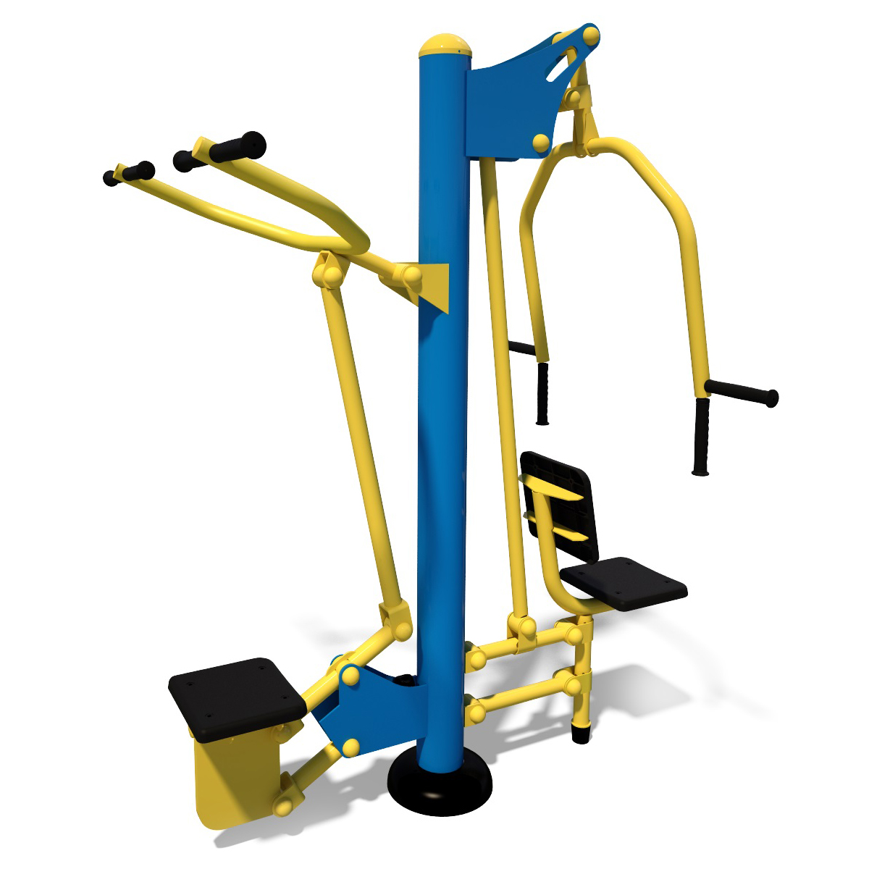](http://diso.interatletika.com/upload/iblock/dfe/0b070a34463511e3b93e002590553bd9_3d6e74c54b1d42da8ade1130fcc77120.jpg)*