**InterAtletika SL 111**

*[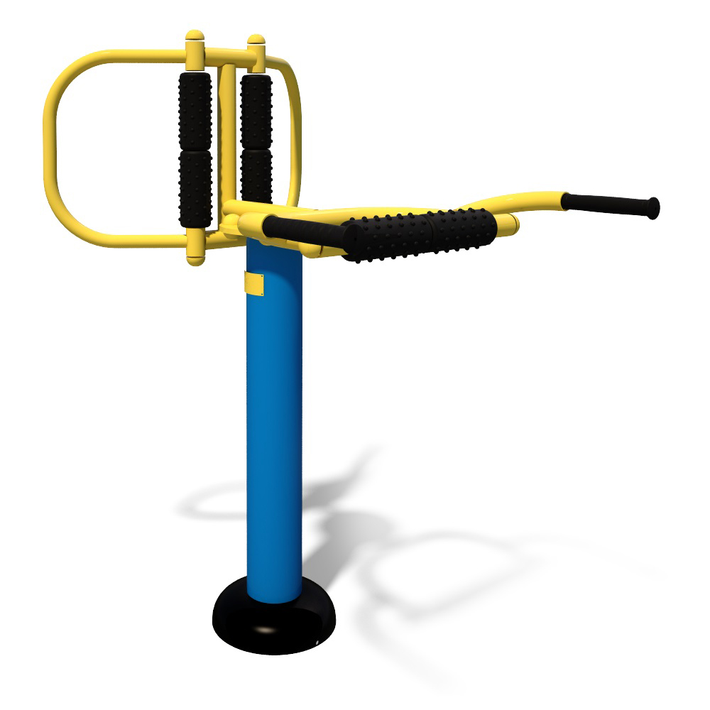](http://diso.interatletika.com/upload/iblock/eac/0b070a3d463511e3b93e002590553bd9_6670def23f8f4ad68ced9c3824078c68.jpg)*