**InterAtletika SL 136.1**

*[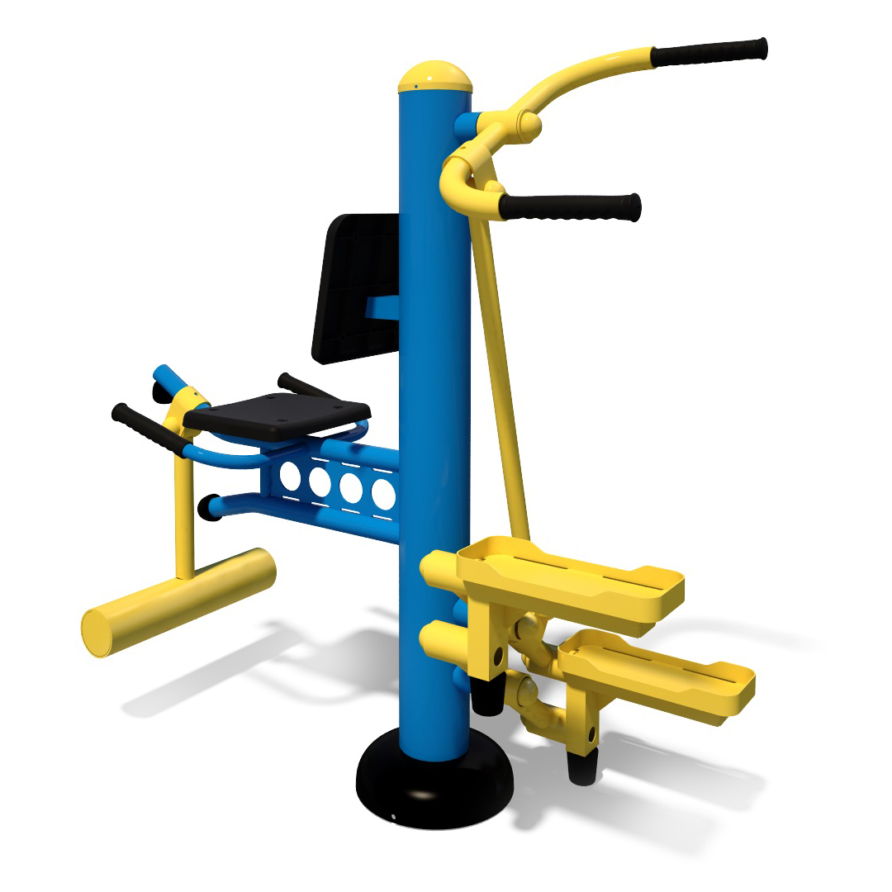](http://diso.interatletika.com/upload/iblock/208/bb3aedf67d7b11e582d2001e676be2c8_889c9f4c5f65491cb2acc500016e80ce.jpg)*