**Фонтанна насадка OASE Schaumsprudler 55-15 E**

[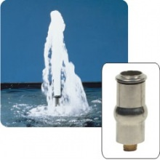](http://www.aquamag.kiev.ua/components/com_jshopping/files/img_products/full_Schaumsprudler_2.jpg)

